1.

2.

3.

4.

5.

6.

7.

8.

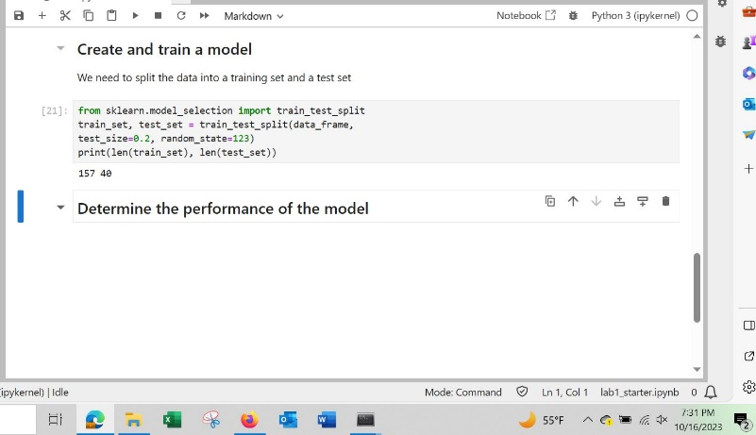

9.

10.

